Creating the directory

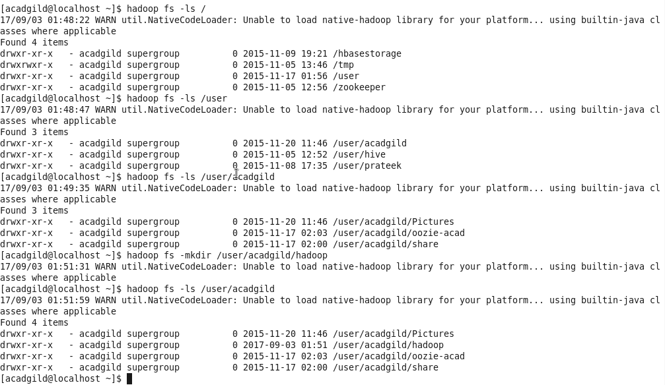

Editing a file



File is found

